Name: Praveer Raj

Roll. No. 1

Reg.No. 230957002

WEEK 4

L4. 1

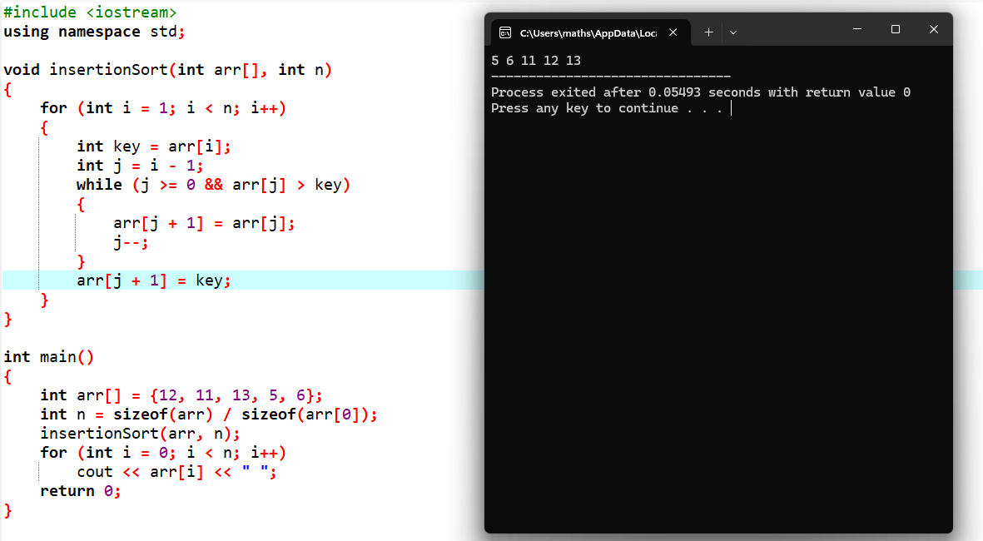

L4. 2

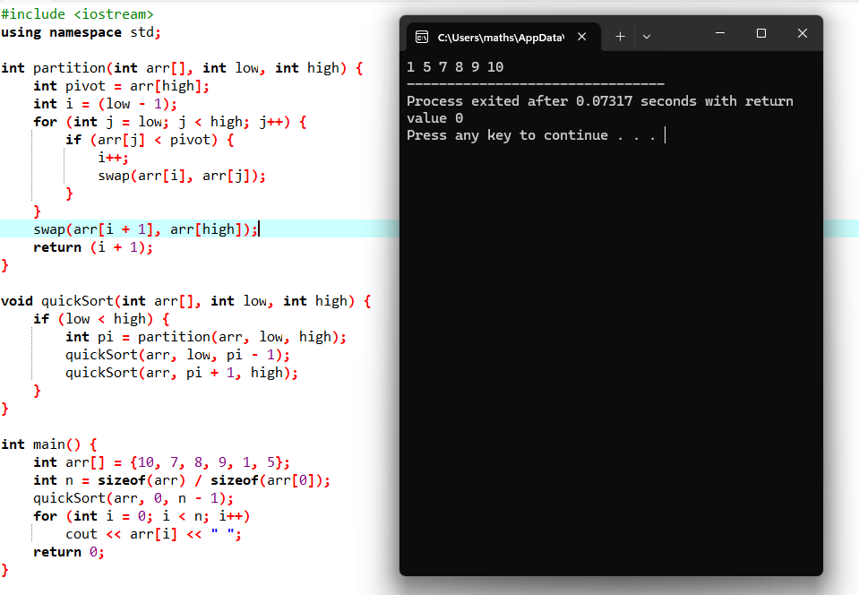

L4. 3

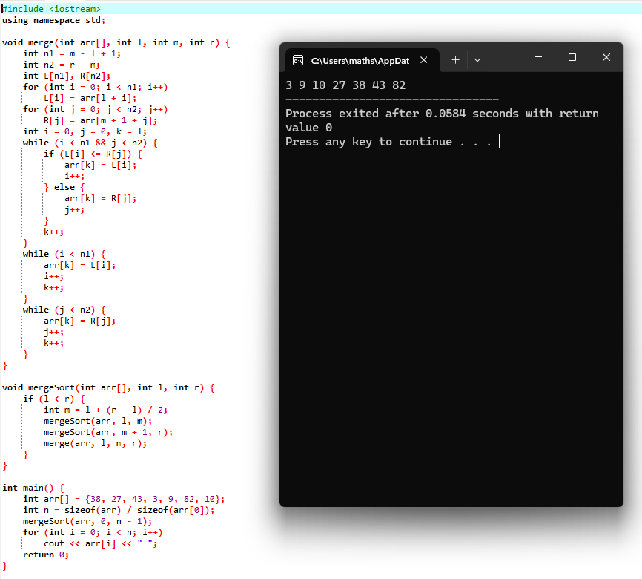

L4. 4

